CLC --- Marketing Expenses, Perceptual Mapping, and Organizational Chart Analysis

June 30th, 2021

CLC --- Marketing Expenses, Perceptual Mapping, and Organizational Chart Analysis
Part 1: Marketing Expenses Versus Rival Firms
Annual Report Information 2020
$ in Millions
Johnson & Johnson Procter & Gamble L’Oreal
Marketing/Advertising Expense $22,084 $19,994 $15,321
Prepare a 250-750-word report to suggest implications for your company in terms of marketing or advertising expenditures going forward as needed to implement strategies
Part 2: Perceptual Mapping
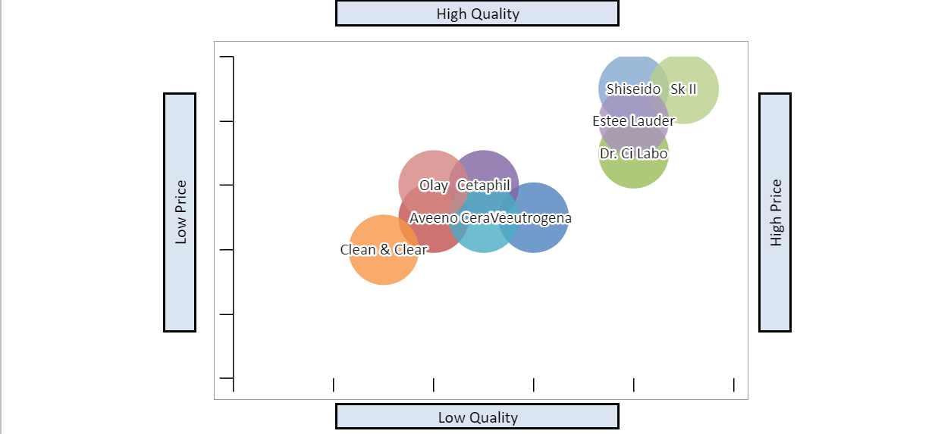

This perceptual map is for Johnson & Johnson’s (J & J) skin care brands and six competitors. Since J & J competes in the pharmaceutical, medical devices, and consumer health industry, there is no direct competitor. The perceptual map will focus on J & J’s skin care products, which includes Neutrogena, Aveeno, Clean & Clear, and Dr. CiLabo, against competitors for price and quality. Using these products with perceptual mapping helps strategists ensure that money for marketing is spent wisely (David et. al., 2020). This map will also help the company understand which brands are doing well, identify problems with underperforming brands, and to visualize potential markets that could serve as a new focus for the company (David et. al., 2020).
All four Johnson & Johnson (J & J) brands span multiple price points and cater to multiple audiences. The organization does well for having all products dermatologists recommended. In the US, J & J products have the highest market share for skin health products with 52% (Diment, 2020). It is not recommended to diversify the brands, but to have Clean & Clear’s marketing team focus on spotlighting that its products do not contain fragrance or dyes and does not leave residue after rinsing (Diment, 2020). The same recommendation would be suggested for Dr. CiLabo’s and focus that this brand is the number one doctor recommended products. With focus on Clean & Clean and Dr. CiLabo, this will boost awareness of the both brands.
Part 3: Organizational Chart Analysis
Current Organization Chart:
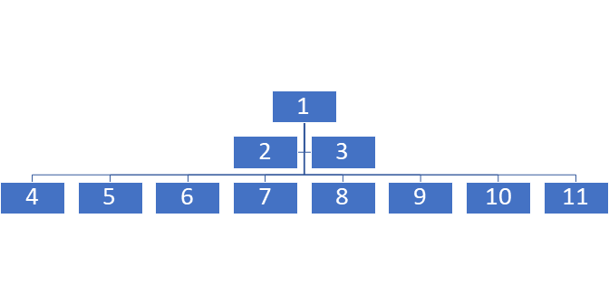

1 - Chairman of the Board/CEO
2 - Vice Chairman of Executive Committee
3 – Vice Chairman of Executive Committee and Chief Scientific Officer
4 - Executive Vice President, Chief Human Resources Officer
5- Executive Vice President, Worldwide Chairman, Medical Devices
6 - Executive Vice President, Worldwide Chairman, Consumer Health
7 - Executive Vice President, Global Corporate Affairs Officer & Chief Communications Officer
8 – Executive Vice President, Worldwide Chairman, Pharmaceuticals
9 – Executive Vice President, General Counsel
10 – Executive Vice President & Chief Global Supply Chain Officer
11 – Executive Vice President & Chief Financial Officer

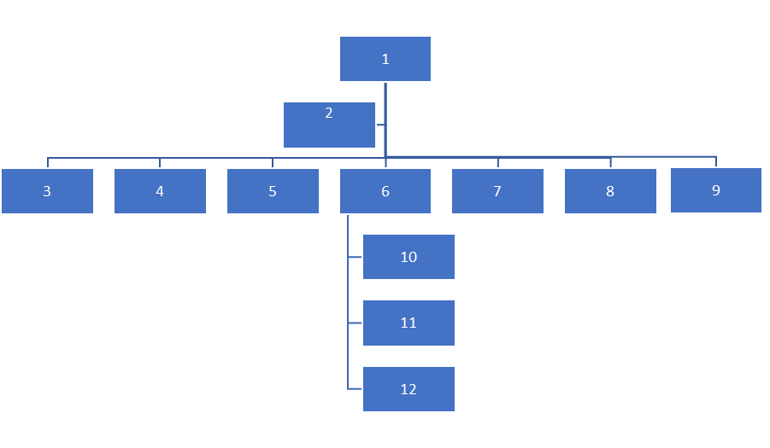

1 – Chairperson of the Board
2 – CEO
3 – Chief Scientific Officer
4 – Chief Human Resources Officer
5 – Chief Global Corporate Affairs Officer
6 – Chief Financial Officer
7 – Chief Communications Officer
8– Chief General Counsel
9 – Chief Global Supply Chain Officer
10 – President of Worldwide Pharmaceuticals
11 – President of Worldwide Medical Devices
12 – President of Worldwide Consumer Health

Write a 250-500-word overview to detail the specific changes, associated costs, and recommendations you made

References
David, F. R., David, F. R., & David, M. E. (2020). Strategic management concepts and cases: A competitive advantage approach (17th ed.). New York, NY: Pearson Education.
Diment, D. (2020). Acne treatment manufacturing OTC. https://my-ibisworld-com.lopes.idm.oclc.org/us/en/industry-specialized/od4125/about
Johnson & Johnson. (2021). Investors information. www.investor.jnj.com
Johnson & Johnson. (2021). Our leadership team. https://www.jnj.com/leadership/our-leadership-team?utm_source=bing&utm_medium=cpc&utm_campaign=BI-USA-ENG-PS-Corporate+Equity-BC-EX-RN-BRAND_LEADERSHIP&utm_content=J%26J+-+Leadership+-+General+-+E&utm_term=johnson+and+johnson+executives&gclid=a44c9734ffca1be220adf7e05b8a56a9&gclsrc=3p.ds&ds_rl=1262818&msclkid=a44c9734ffca1be220adf7e05b8a56a9
Leighton, M. & Decker-Jacoby, K. (2021). The Insider reviews team test hundreds of skincare brands each year – these are the 24 we keep coming back to. https://www.insider.com/best-skincare-brands
Procter & Gamble. (20210. 2020 annual report. https://us.pg.com/annualreport2020/annual-report-downloads/
Rosenstien, J. (2021). The 35 best skincare brands. https://www.harpersbazaar.com/beauty/skin-care/g19738338/best-skin-care-brands
Thomas, B. (2021). Cosmetic & beauty products manufacturing in the US. https://my-ibisworld-com.lopes.idm.oclc.org/us/en/industry/32562/major-companies
Yahoo! Finance. (2021). L’oreal income statement. https://finance.yahoo.com/quote/OR.PA/financials/

